**P.E. / Dance**

Explorers travelling to the artic would need to be strong, agile and flexible! See the attached sheets full of activities to make you explorer ready!

See if you can create and make your own polar menu using the attached sheets.

**Science**

The few areas where there is no or only little ice throughout the year are home to small scrubs, grasses and mosses. Not many species actually live on the Antarctic continent. Whales, and seals live in the Southern Ocean surrounding Antarctica. The Emperor penguins are the only penguin species breeding on Antarctica.

Have a look at some online facts about Emperor penguins and see if you can make an interactive poster about them.

Online magic melting ice cubes experiment <https://www.stem.org.uk/elibrary/resource/32070>

Snow ice, and water clip to watch <https://www.bbc.co.uk/bitesize/clips/zn3ygk7>

**Geography**

We have now signed up to Digimap for schools, an online mapping service which has fantastic links to the national curriculum. To log in, visit <https://digimapforschools.edina.ac.uk/>. Familiarise yourself with the programme.

Can you identify the Antarctic Circle, the Equator and the Northern and Southern Hemisphere on the map?

Compare the size of Antarctica against other continents or countries.

How many times bigger than Australia is it?

Why is Antarctica considered a desert if it is not hot?

How many square kilometres is Antarctica?

What is the longest river in Antarctica?

Prior learning: How is this place different or similar to Australasia?

Print out a map and plot the points of the journey that Shackleton made.

**Username:**

**B735SD**

**Password: conths2385**

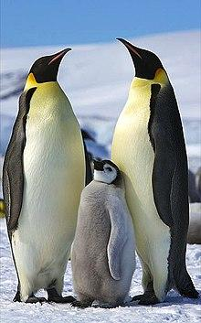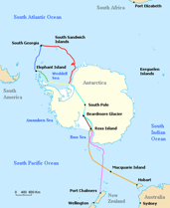

**Design and Technology**

**Sledging biscuits in Antarctica are one of the two foods that Antarctic exploration was built on.** Why not use the following link to bake your own sledging biscuits (<https://www.coolantarctica.com/schools/antarctic_sledging_biscuit_recipe.php> ). Ask people in your family to give them a taste and a rate!

Research what the sledge was like that Shackleton used. Using recycled boxes, cardboard etc can you make a sledge? Can you pull your teddies around on the sledge without it breaking? What did you find difficult - why? Tweet us your pictures!

**Music**

**Listen and Appraise: Artic Breath:** <https://www.youtube.com/watch?v=BPDraSLAu_w>

What do you visualise as you listen to this song?

Can you draw the scene?

Can you choose an appropriate adjective to describe the timbre of the music?

**Challenge: African Skies**

<https://www.youtube.com/watch?v=rq9yhEkMXMU>

Compare the two pieces of music.

What do you visualise in this piece?

What are the similarities and differences?

**Boldmere Junior Explorers Project**

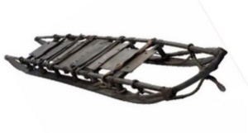**The Continent of Antarctica**

**Computing**

(Links with Geography and History) Research the continent of Antarctica. Can you make a poster/ leaflet (using word or publisher) sharing your findings? https://www.activewild.com/antarctica-facts-for-kids/ is a great and safe website to use.

Can you make a scratch animation using an Antarctica backdrop and animals that would live there? Try to add motion and sound to your animation.

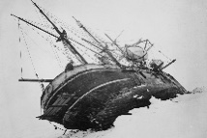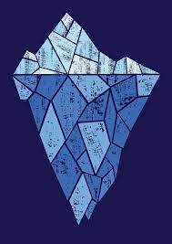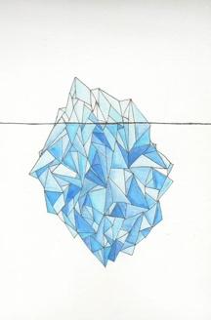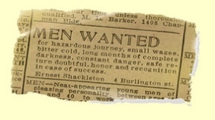

**History**

Create a **chronological** timeline of the exploration of Antarctica.

Learn about Robert Falcon-Scott here: <https://www.bbc.co.uk/teach/class-clips-video/ks2-robert-falcon-scott/zdhdgwx>

The most famous explorers of Antarctica created a heritage of exploration and scientific study of the most remote and mesmerising continent on our planet.

Research Sir Ernest Shackleton and create a fact file or a diary about his adventures.

What can you find out about his ship ‘The Endurance’? Why did they abandon the ship?

If Sir Ernest Shackleton wrote you a postcard from Antarctica. What would he write?

**R.E. / P.S.H.E.**

What are the beliefs and religions of the people of Antarctica?

Links to prior learning: What are the beliefs of the Australasian people? Create a table to compare the similarities and differences.

How would it feel to live in such an extreme place as Antarctica? Write a poem thinking about your feelings.

Here is the advert for the

Endurance expedition.

Would you have signed up? Why?

**Art and Design**

Icebergs are made of freshwater ice that used to be part of a glacier. They spend months or years floating around the seas of Antarctica eroding and repeatedly tipping up, showing all sorts of blue shades in the process. Much of an iceberg is below the surface.

Can you create a piece of geometric art based on an iceberg? <https://www.youtube.com/watch?v=obrOIE2M3KU> **Challenge:** Create an icy scene reflecting in the water.