Ancient Egyptian Gods and Goddesses
For all ancient people, the world was filled with mystery. Much of what they experienced in the world around them was unknowable and frightening. The ancient Egyptian gods and goddesses represented aspects of the Egyptians’ natural and “supernatural” surroundings and helped them understand its many aspects.

Nut, Shu and Geb
Nut was the mother of Osiris, Isis, Seth, and Nephythys, Nut is usually shown in human form; her elongated body symbolizing the sky. Nut swallowed the setting sun (Ra) each evening and gave birth to him each morning. She is often depicted on the ceilings of tombs, on the inside lid of coffins, and on the ceilings of temples.

Shu was the husband of Tefnut and the father of Nut and Geb. He and his wife were the first gods created by Atum. Shu was the god of the air and sunlight. He was normally depicted as a man wearing a headdress in the form of a plume, which is also the hieroglyph for his name.
Shu’s function was to hold up the body of the goddess Nun and separate the sky from the earth.
Geb was the father of Osiris, Isis, Seth, and Nephythys. As an Earth god he was associated with fertility and it was believed that earthquakes were the laughter of Geb.

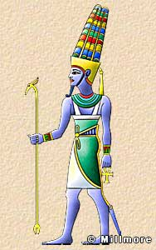
Amun Amun was the patron of the Theban pharaohs and was eventually combined with sun god, Ra who had been the dominant deity of the Old Kingdom to become Amun-Ra, King of the Gods and ruler of the Great Ennead.

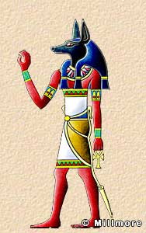
Anubis Protector of the Dead Anubis is shown as a jackal-headed man, or as a jackal. His father was Seth and his mother Nephythys. He was closely associated with mummification and as protector of the dead.

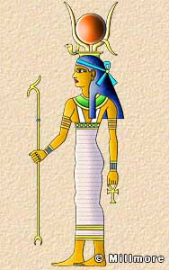
Hathor Hathor was the daughter of Ra and the patron goddess of women, love, beauty, pleasure, and music. She is depicted in three forms; as a cow, as a woman with the ears of a cow, and as a woman wearing the headdress of a cow’s horns.
There was a dark side to Hathor. It was believed that Ra sent her to punish the human race for its wickedness, but Hathor wreaked such havoc on earth that Ra was horrified and determined to bring her back.

Horus Horus was the son of Osiris and Isis and the enemy of the wicked God Seth. He is depicted as a hawk or as a man with the head of a hawk. He was the god of the sky and the divine protector of kings.
There are many stories of his wars against his uncle Seth, who murdered his father and usurped the throne.

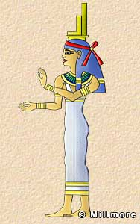
Isis Isis was the wife of Osiris and mother of Horus. She was associated with funeral rites and said to have made the first mummy from the dismembered parts of Osiris. As the enchantress who resurrected Osiris and gave birth to Horus, she was also the giver of life, a healer and protector of kings.

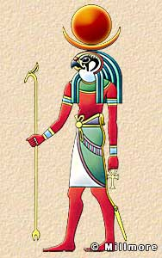
Khonsu Khonsu was the son of Amun and Mut. He was a moon god depicted as a man with a falcon-head wearing a crescent moon headdress surmounted by the full lunar disc. Khonsu was believed to have the ability to drive out evil spirits. Rameses II sent a statue of Khonsu to a friendly Syrian king in order to cure his daughter of an illness.

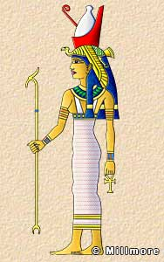
Mut Mut formed part of the Theban Triad. She was one of the daughters of Ra, the wife of Amun, and mother of Khonsu. She was the Vulture goddess and is often depicted as a woman with a long, brightly coloured dress and a vulture headdress surmounted by the double crown.
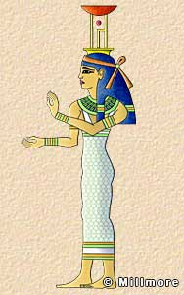

Nephythys Daughter of Geb and Nut, sister of Isis, wife of Seth and mother of Anubis, Nephythys is depicted as a woman with the hieroglyphs for a palace and ‘Neb’ (a basket) on her head. She is thus known as “Lady of the Mansions” or “Palace.”

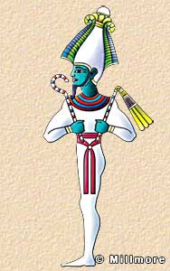
Osiris Osiris was originally a vegetation god linked with the growth of crops. He was the mythological first king of Egypt and one of the most important of the gods. It was thought that he brought civilization to the race of mankind. He was murdered by his brother Seth, brought back to life by his wife Isis, and went on to become the ruler of the underworld and judge of the dead.
He is usually depicted as a mummy holding the crook and flail of kingship. On his head he wears the white crown of Upper Egypt flanked by two plumes of feathers. Sometimes he is shown with the horns of a ram. His skin is depicted as blue, the color of the dead; black, the color of the fertile earth; or green, representing resurrection.

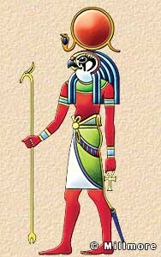
Ra The supreme sun god was represented as a man with the head of a hawk, crowned with a solar disk and the sacred serpent.
Each day Ra travelled across the sky in the form of the sun, riding in his solar boat, and each night he journeyed through the underworld where he defeated the allies of chaos. He was reborn each morning in the form of the sunrise.

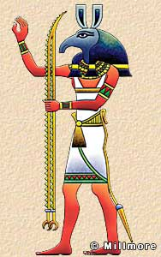
Seth Also known as Set, Seth was the son of Geb and Nut, and the evil brother of Osiris. He was the god of darkness, chaos, and confusion, and is represented as a man with an unknown animal head. He is sometimes depicted as a hippopotamus, a pig, or a donkey. Seth murdered his brother and usurped the throne of Egypt and most of the other gods despised him.
Horus eventually defeated Seth, but it was thought that their battle was an eternal struggle between good and evil. Although Seth failed to keep the throne of Egypt he continued to be a companion of Ra. He sometimes accompanied Ra across the sky in his solar boat, causing storms and bad weather.

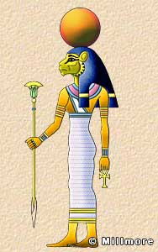
Tefnut Tefnut was the wife of Shu and mother of Nut and Geb. She was the goddess of moisture or damp, corrosive air, and was depicted either as a lioness or as a woman with a lioness’s head.

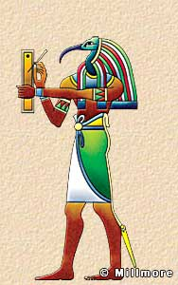
Thoth Thoth was the god of writing and knowledge, and was depicted as a man with the head of an ibis holding a scribe’s pen and palette, or as a baboon. One of his most important roles was to record the deeds of the dead at the day of their judgment and is often seen doing this in the Book of the Dead.

