[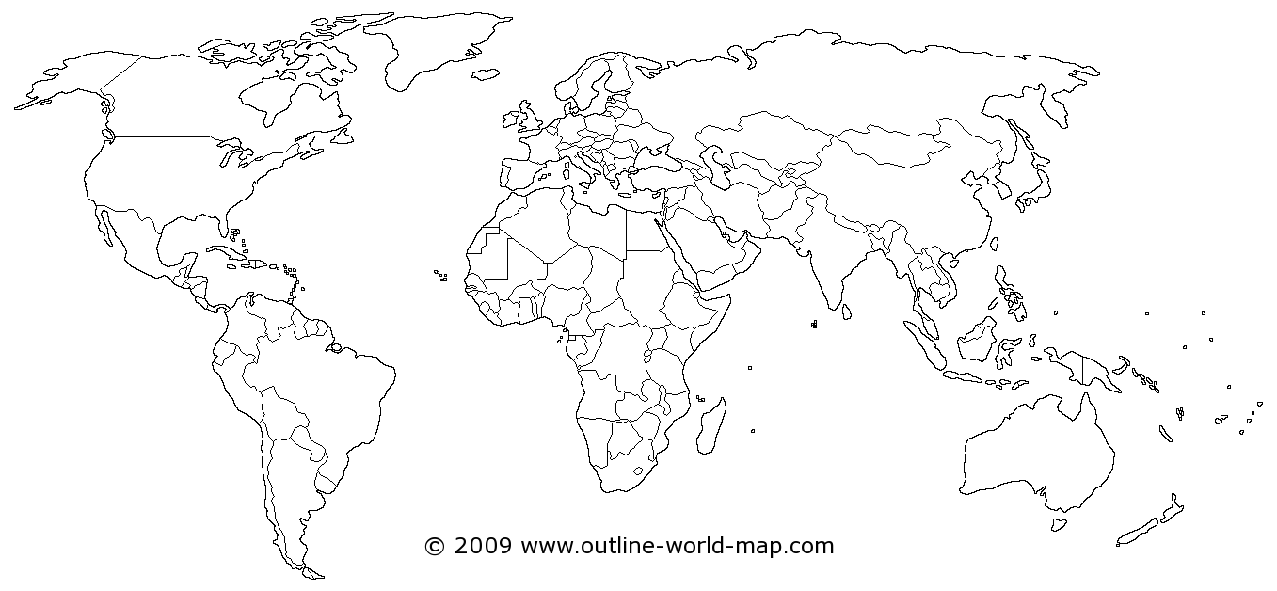](http://www.outline-world-map.com/white-transparent-political-world-map-b)