Australian City | Population
Sydney | 10,000
Central Coast | 8500
Cairns | 6000
Perth | 5000
Geelong | 500
Gold Coast – Tweed Heads | 0
Newcastle – Maitland | 2000
Canberra – Queanbeyan | 8000
Bronze- Create a bar chart to show this information. It has been started for you!

Disclaimer: these numbers are totally made up by Miss Jackson

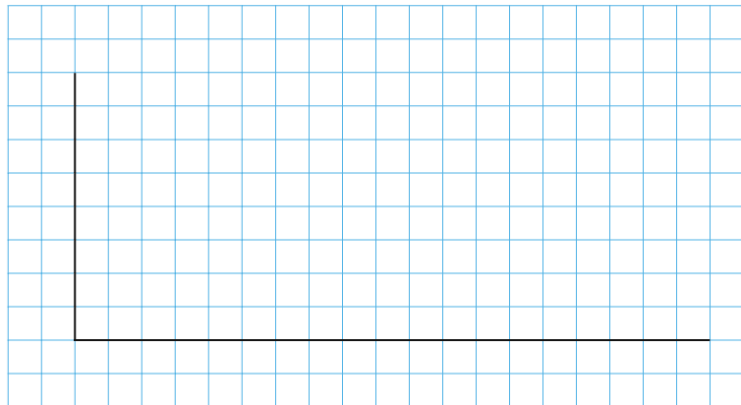
10,000

2000
1000
0
Sydney
Central Coast

