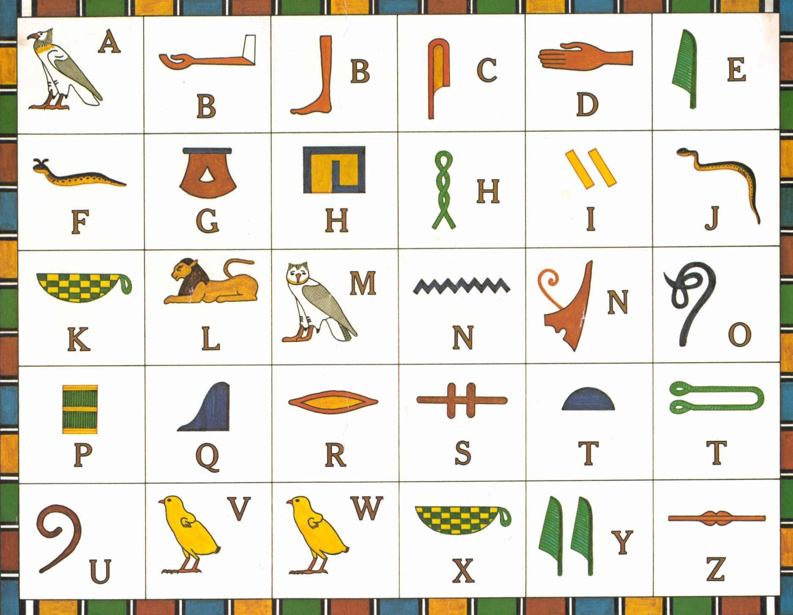

Crack the code blow using the hieroglyphs



_ _ _ _ _ _ _ _ _ _ _ _



_ _ _ _ _ _ _ _ _ _ _ _

Extension: Write your own message using the hieroglyphs alphabet!