Gold Task 2
Kelly chooses a section of a newspaper.
It has 50 words in it.
She draws a bar chart of the number of letters in each word.
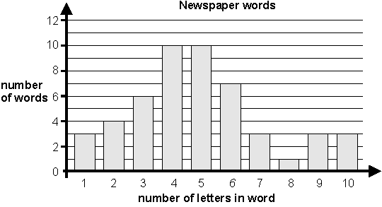

What fraction of the 50 words have more than 6 letters?

1 mark

Kelly says,
23 of the 50 words have less than 5 letters.
This shows that nearly half of all the words used in the newspaper have less than 5 letters in them.
Explain why she could be wrong.
...............................................................................................................................
...............................................................................................................................
...............................................................................................................................
1 mark
Q4. A school collects money for charity.
This chart shows how much has been collected.
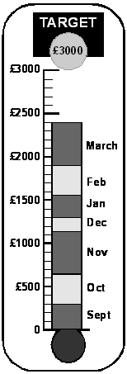

The target is £3000.
Estimate how much more money the school needs to reach the target.

£

1 mark

Anil says,
The chart shows that we will reach the target in two months.
Use the chart to explain why Anil may be wrong.
...............................................................................................................................

Q5. Here is a bar chart showing rainfall.
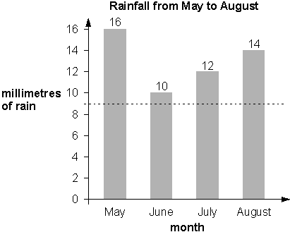
Kim draws a dotted line on the bar chart.
She says,
‘The dotted line on the chart shows the mean rainfall for the four months.’

Use the chart to explain why Kim cannot be correct.
...............................................................................................................................
...............................................................................................................................
...............................................................................................................................
1 mark

What is the mean rainfall for the four months?

mm

1 mark

Q10.
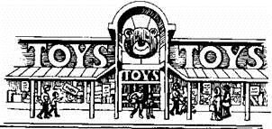
This chart shows the amount of money spent in a toy shop in three months.
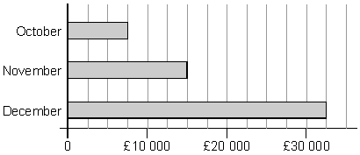

How much more money was spent in the shop in December than in November?

£

1 mark

Stepan says,
‘In November there was a 100% increase on the money spent in October’.
Is he correct?
Circle Yes or No. Yes / No
Explain how you can tell from the chart.
...............................................................................................................................
..............................................................................................................................

Q13. Some children take part in the long jump.
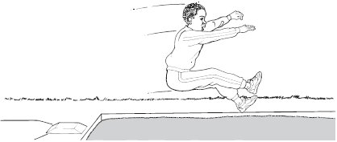

The graph shows the distances the children jumped.
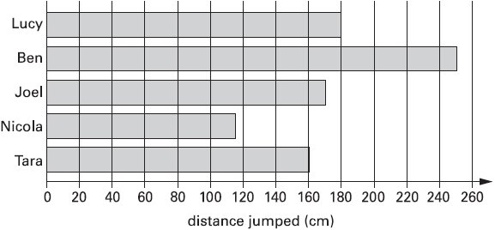

Estimate how much further Lucy jumped than Nicola.

cm

1 mark

Q17. All the children at Park School chose their favourite soup.
The graph shows the results.
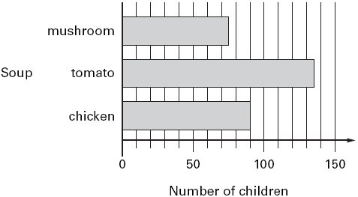

How many more children chose chicken soup than mushroom soup?
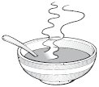

1 mark

Robbie says,
‘More than half of the children chose tomato soup’.
Is he correct?
Circle Yes or No.
Yes / No
Explain how you can tell from the graph.
...............................................................................................................................

