How to log into my school email and access Google Classroom
Please follow this step by step guide, in order to access Google Classroom and your child’s Remote Learning.
Accessing Google Classroom:
- Click on google chrome and type in office 365- https://www.office.com/
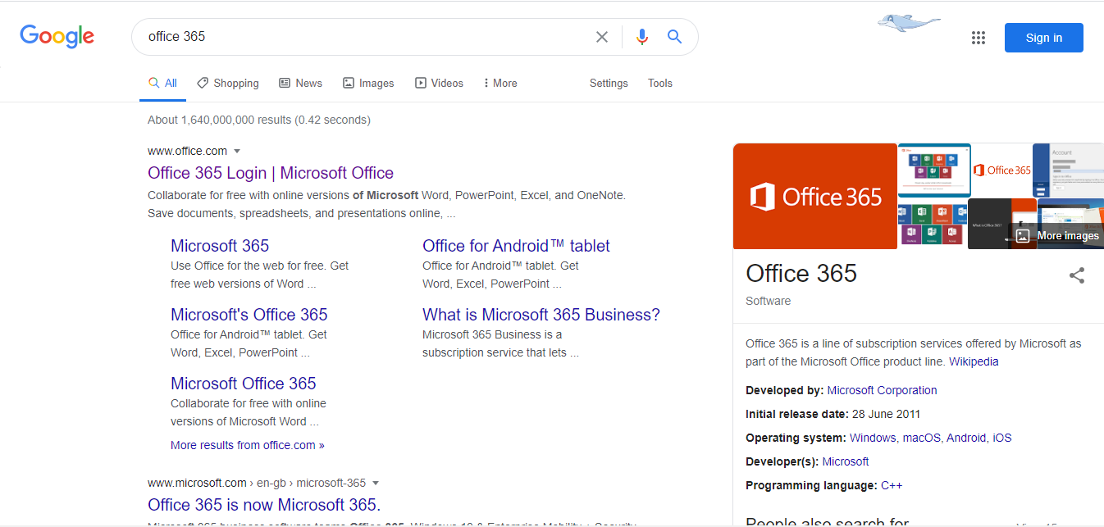
- Click on ‘sign in’ and type in your school email address and password.
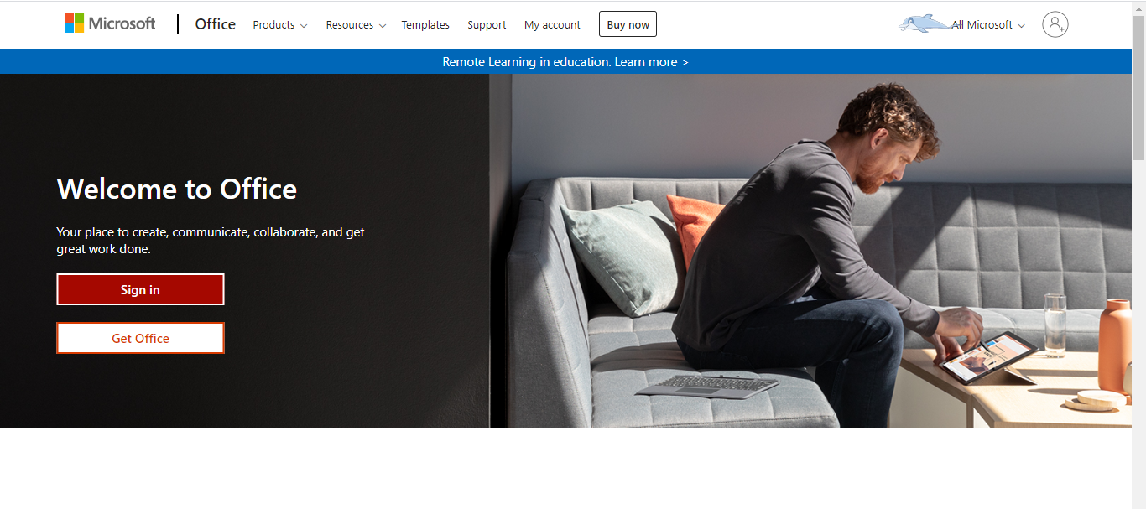
- You should see this screen. Click on ‘outlook’ to access your emails.
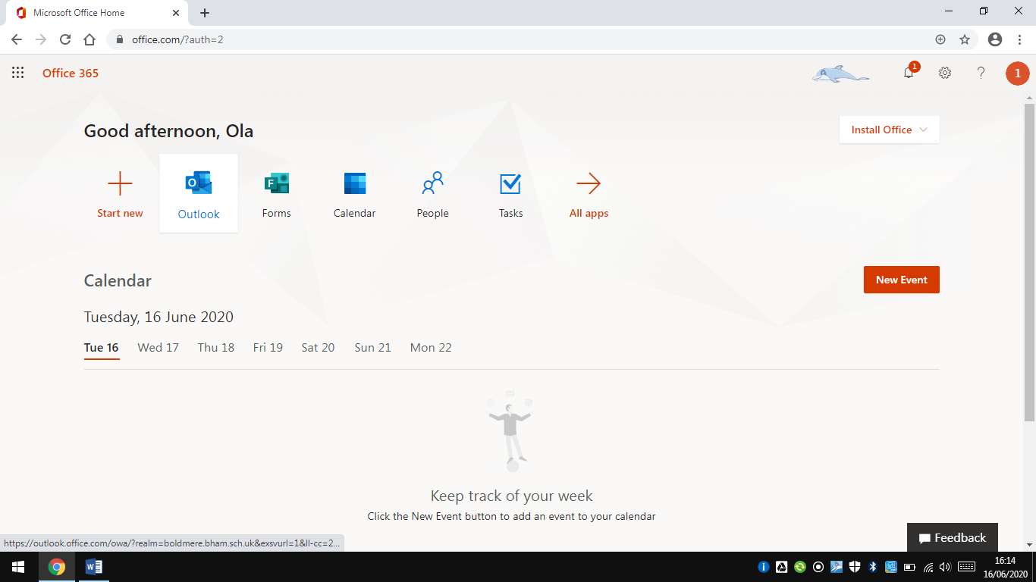

- After, click on the icon in the left hand corner.
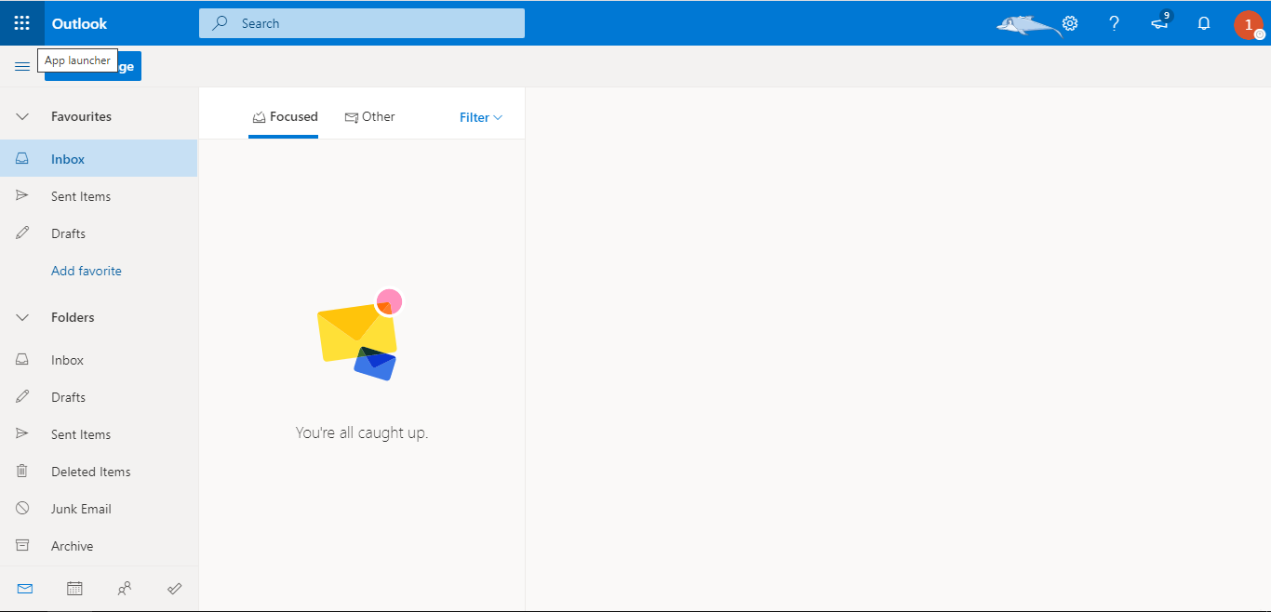
- Click on all apps. Then google drive. You should see this screen. (Below)
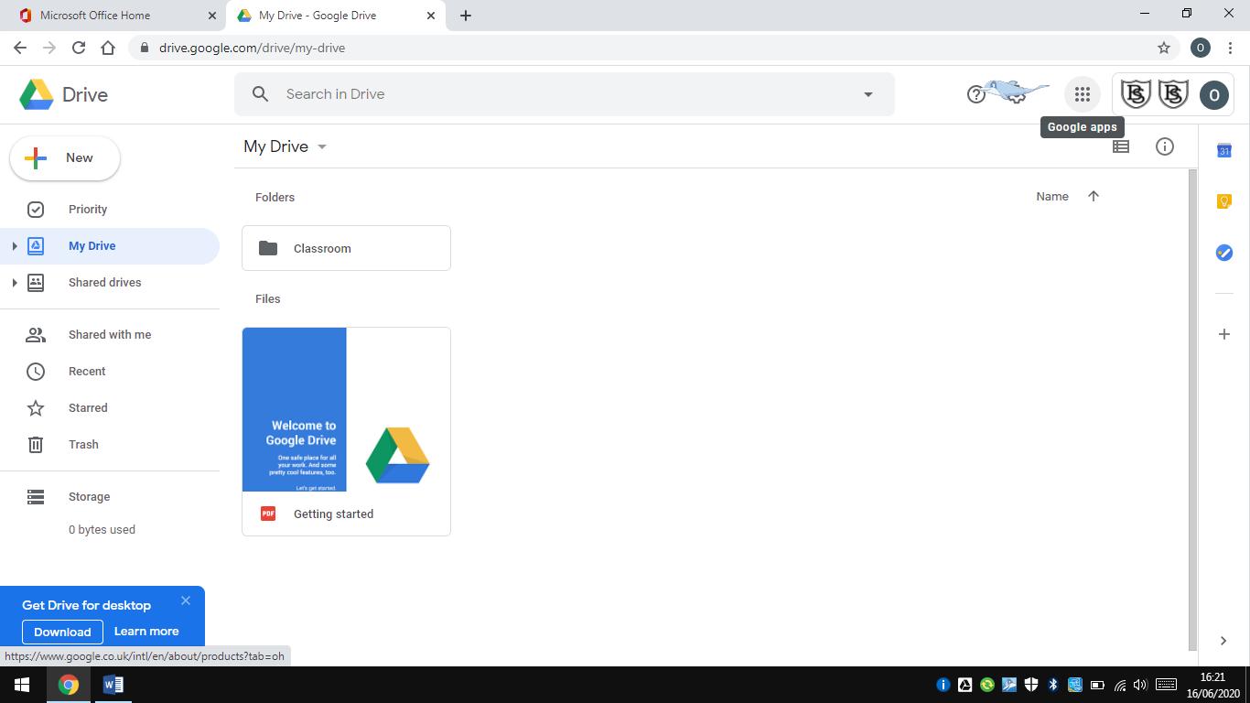
- Then click on the same icon (this time it’s in the right-hand corner) and click on the classroom icon. You should see this screen:
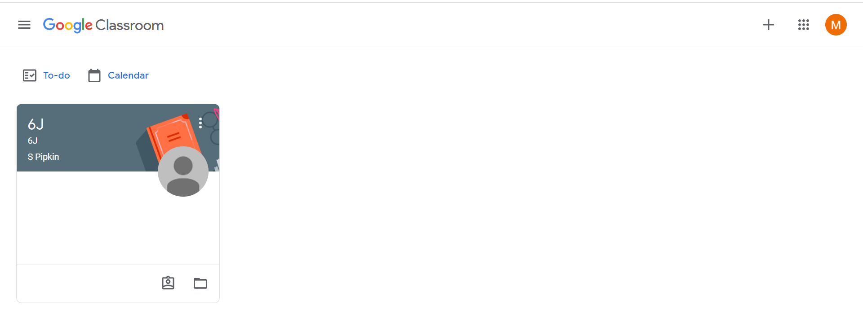

- You will now be able to access the ‘Stream’, which is where your child’s teacher can post any messages for the class.
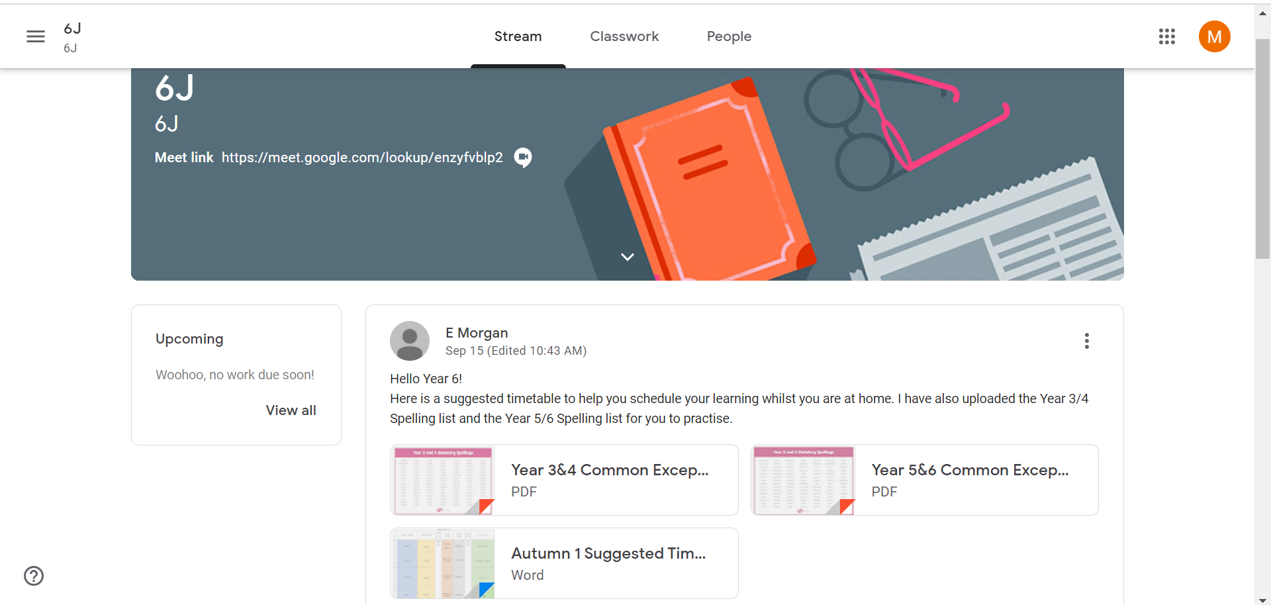
Accessing the Remote Learning:
- You will now be able to access the ‘Classwork’ section which has all of your child’s work uploaded for the week. You will see all of the Topics (subjects) down the left-hand side.
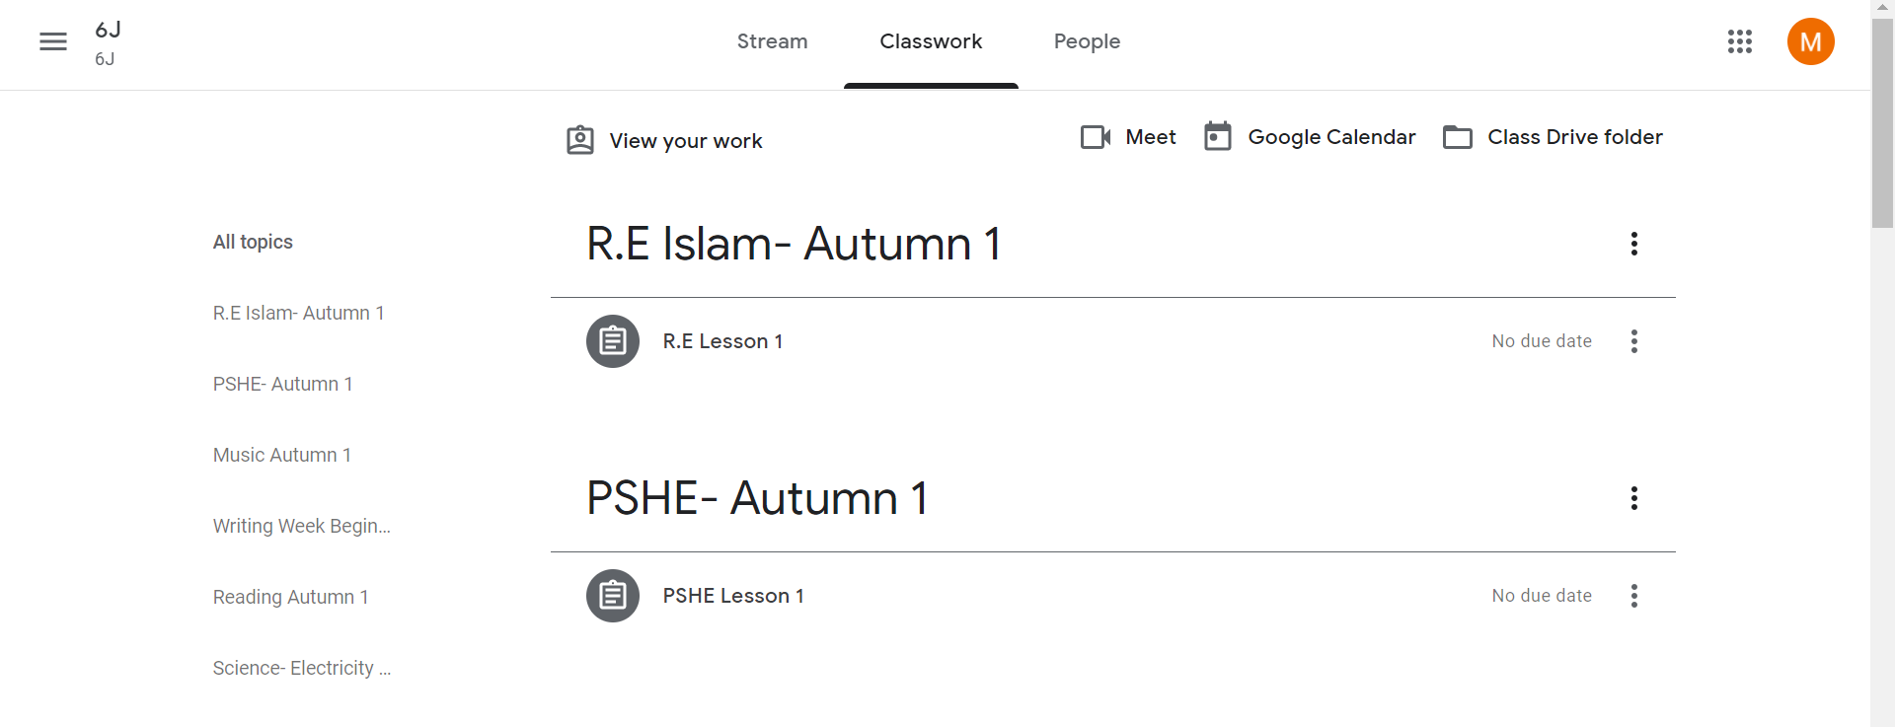
- You will find that some of the lessons that have been set, have come directly from the National Oak Academy. For these lessons, click on the link and you will be taken directly to the Oak Academy website.
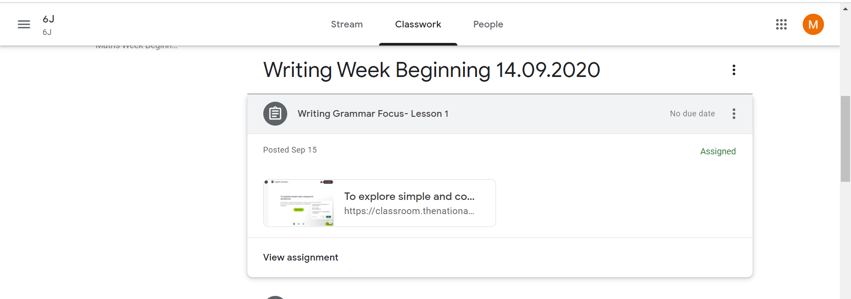
These lesson use a video link which will start when you click ‘Start Lesson’. Some of the lessons have separate resources, but most lessons have the activities within the video clip and a quiz to finish.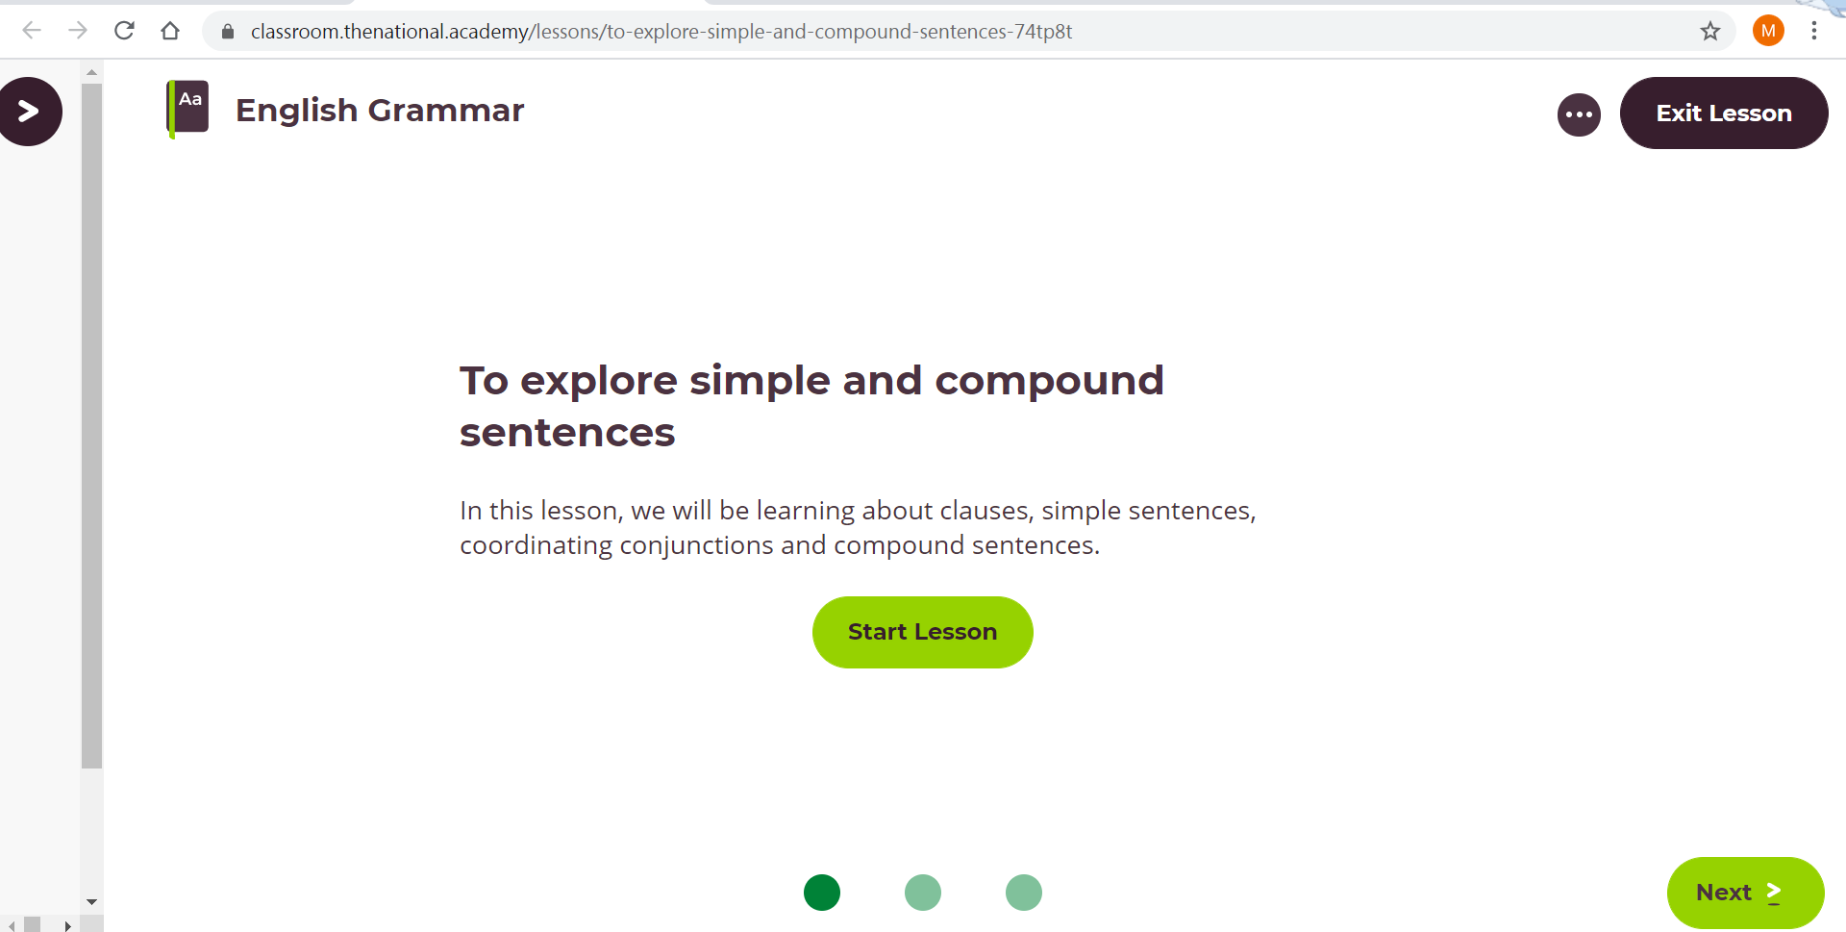
- You will also find that some of the lessons that have been set, have come directly from the lessons that would take place in the classroom.
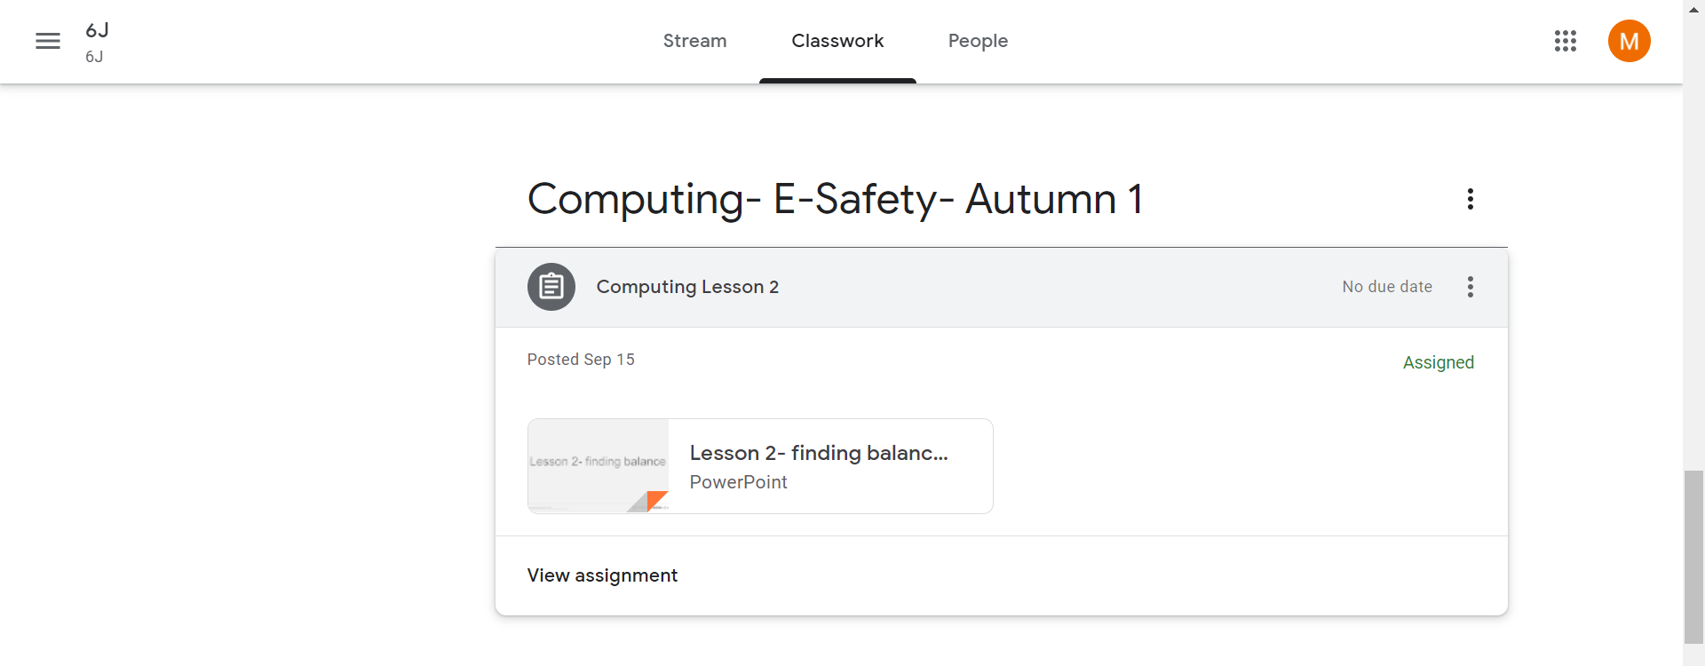
Some of these lesson will have a PowerPoint with the activities included, whereas, some lessons will also have some resources attached with the activities.
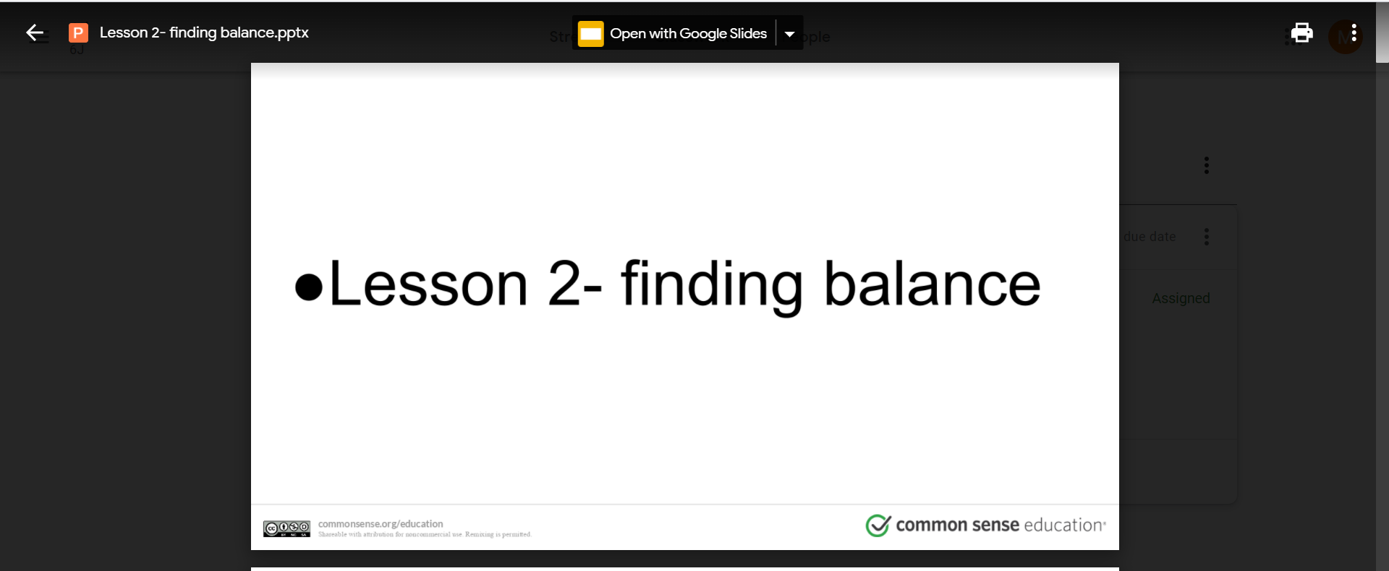

- Once your child has completed the lesson, they can go back on to their Google Classroom and click ‘View Assignment.
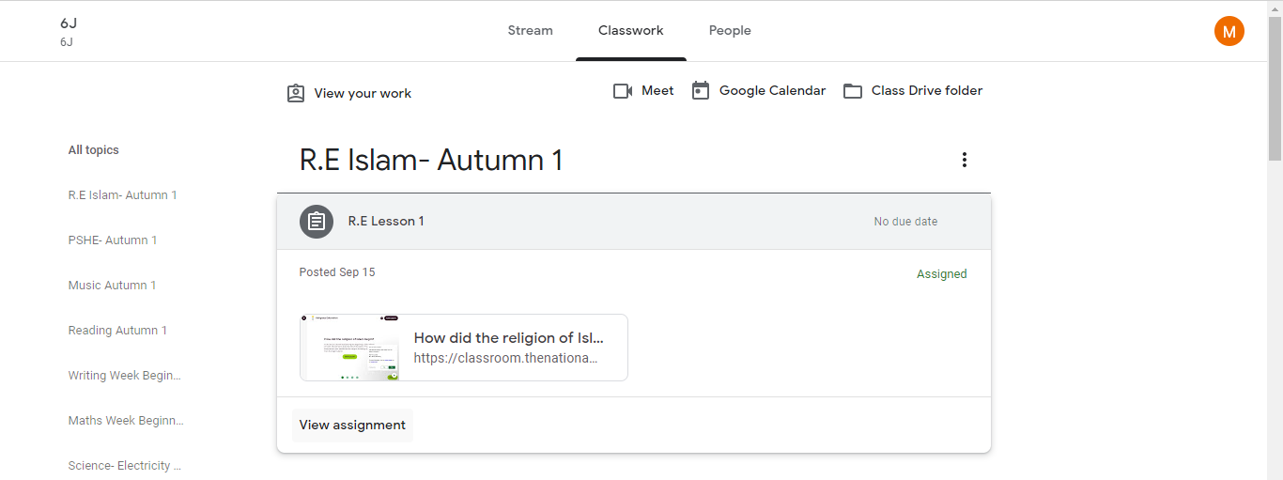
This page will then load where they can add their work as an attachment and click, ‘Mark as done’. If your child has any questions or comments about the work, they can also type them here.
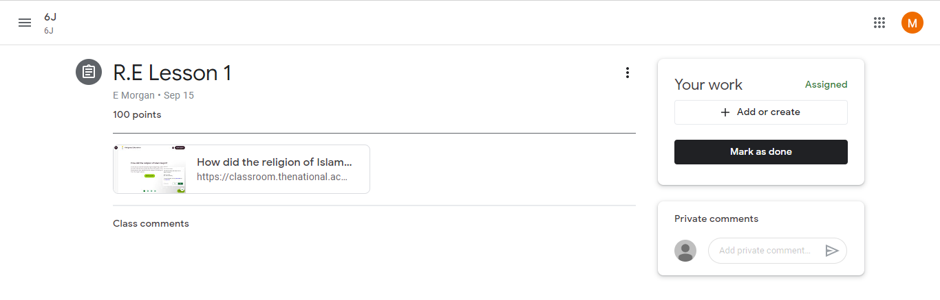
Google Classrooms will be uploaded weekly with a new set of lessons. Any problems, please contact enquiry@boldmere.bham.sch.uk and we will try to rectify as soon as possible.
Thank you for your co-operation and patience.

