Trip Planning Information Pack
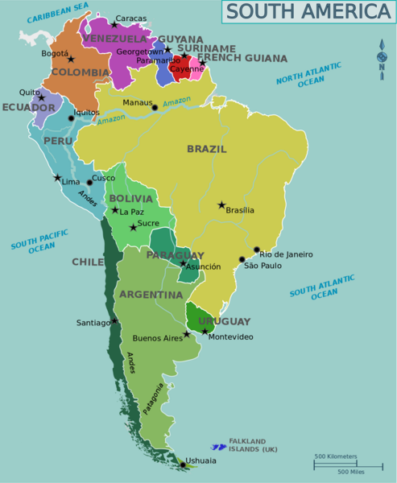

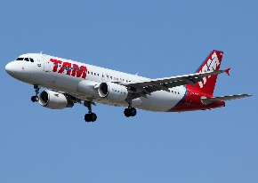
Cost of Flights Around South America

Flights from Rio de Janeiro
Buenos Aires (Argentina) - £383
Bogota (Colombia) - £1176
Santiago (Chile) - £574
Lima (Peru) - £430
Quito (Ecuador) - £1485
Caracas (Venezuela) - £967
Montevideo (Uruguay) - £386
Sucre (Bolivia) - £889

Flights from Bogota
Buenos Aires (Argentina) - £1430
Rio de Janeiro (Brazil) - £1164
Santiago (Chile) - £851
Lima (Peru) - £167
Quito (Ecuador) - £562
Caracas (Venezuela) - £364
Montevideo (Uruguay) - £1169
Sucre (Bolivia) - £1096

Flights from Buenos Aires
Rio de Janeiro (Brazil) - £357
Bogota (Colombia) - £1063
Santiago (Chile) - £348
Lima (Peru) - £633
Quito (Ecuador) - £1254
Caracas (Venezuela) - £861
Montevideo (Uruguay) - £132
Sucre (Bolivia) - £529

Flights from Santiago
Buenos Aires (Argentina) - £1430
Rio de Janeiro (Brazil) - £1164
Santiago (Chile) - £851
Lima (Peru) - £167
Quito (Ecuador) - £562
Caracas (Venezuela) - £364
Montevideo (Uruguay) - £1169
Sucre (Bolivia) - £1096
Flights from Lima
Buenos Aires (Argentina) - £660
Bogota (Colombia) - £482
Santiago (Chile) - £346
Rio de Janeiro (Brazil) - £885
Quito (Ecuador) - £403
Caracas (Venezuela) - £685
Montevideo (Uruguay) - £917
Sucre (Bolivia) - £1096

Flights from Quito
Buenos Aires (Argentina) - £1546
Bogota (Colombia) - £560
Santiago (Chile) - £801
Lima (Peru) - £518
Rio de Janeiro (Brazil) - £2271
Caracas (Venezuela) - £597
Montevideo (Uruguay) - £1097
Sucre (Bolivia) - £2018

Flights from Caracas
Buenos Aires (Argentina) - £1868
Bogota (Colombia) - £482
Santiago (Chile) - £1116
Lima (Peru) - £593
Quito (Ecuador) - £408
Rio de Janeiro (Brazil) - £2514
Montevideo (Uruguay) - £729
Sucre (Bolivia) - £1650

Flights from Montevideo
Buenos Aires (Argentina) - £245
Bogota (Colombia) - £1010
Santiago (Chile) - £349
Lima (Peru) - £671
Quito (Ecuador) - £634
Caracas (Venezuela) - £1481
Rio de Janeiro (Brazil) - £363
Sucre (Bolivia) - £510

Cost of Accommodation
The following prices are the cost of accommodation for one night and one person in the city stated:
Rio de Janeiro - £202
Buenos Aires – £171
Bogota – £65
Santiago – £131
Lima – £241
Quito – £148
Caracas – £128
Montevideo – £149
Sucre - £61

Cost of Eating Out
The following prices are the cost of eating a three course meal in a restaurant for one person in the city stated:
Rio de Janeiro - £47
Buenos Aires – £39
Bogota – £43
Santiago – £34
Lima – £27
Quito – £49
Caracas – £34
Montevideo – £48
Sucre - £23

Cost of Transport
The following costs are the costs for a day of transport to get around the city stated:
Rio de Janeiro – Bus - £16, Train - £23, Taxi - £35
Buenos Aires – Bus - £19, Train - £32, Taxi - £27
Bogota – Bus - £24, Train - £37, Taxi - £18
Santiago – Bus - £8, Train - £48, Taxi - £7
Lima – Bus - £27, Train - £17, Taxi - £49
Quito – Bus - £38, Train - £5, Taxi - £56
Caracas – Bus - £42, Train - £26, Taxi - £72

Montevideo – Bus - £23, Train- £38, Taxi - £16
Sucre - Bus - £17, Train - £59, Taxi - £24

