Lesson 5 – Multiplication
Bronze- I can multiply by 1 digit numbers using short method.
- 221 x 3 =
- 2736 x 2 =
- 2524 x 5 =
- 1625 x 6 =
- 2615 x 7 =
- 7162 x 4 =

Silver- I can multiply by 2 digit numbers using long multiplication.
1. | 1546 |  | x | 54 =
2. | 1947 |  | x | 21 =
3. | 1324 |  | x | 59 =
4. | 1234 |  | x | 22 =
5. | 3333 |  | x | 22 =
6. | 4864 |  | x | - =

Gold- I can apply these skills to reason and problem solve.
*Complete 2 silver questions first
Find the missing digits

PLEASE TURN OVER

4. Miss Brown knows that
137 × 28 = 3836
Explain how she can use this information to work out this multiplication.
138 × 28

5. A shop sells sheets of sticky labels.
On each sheet there are 36 rows and 18 columns of labels.
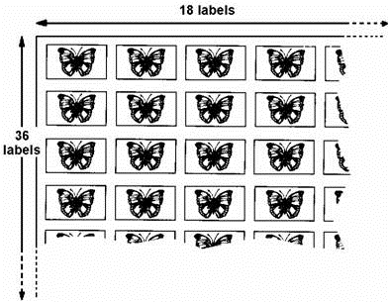
How many labels are there altogether on 45 sheets?

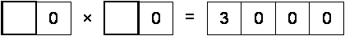
6. Write in the two missing digits.

- This represents the multiplication of a 4 figure number by 3. The whole calculation uses each of the digits 0−9 once and once only.
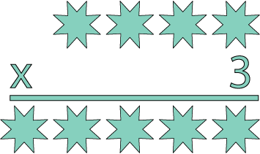
The 4 -figure number contains three consecutive numbers, which are not in order (e.g. 3,1,2). The third digit is the sum of two of the consecutive numbers.

