Lesson 6 – Division

Bronze-I can divide by 1 digit using bus stop

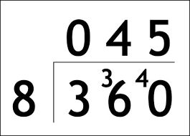
- 312 ÷ 8 = 39
- 306 ÷ 9 = 34
- 684 ÷ 2 = 57
- 382 / 8 = 47r6
- 305 / 7 = 43r4
- 451 / 12 =37r7

Silver- I can divide by 1 digit using long division
- 1288 ÷ 4= 322
- 2568 ÷ 6= 428
- 8118 ÷ 9= 902
- 1893 ÷ 3= 631

Gold 1- I can divide by 2 digits using long division with exchanging
- 7212 ÷ 12 = 601
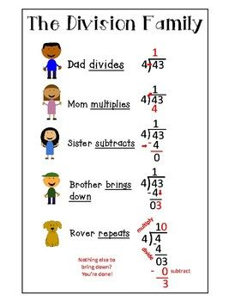
- 4465 ÷ 19 = 235
- 241 ÷ 17 = 14 r3
- 1946 ÷ 31= 62 r24

PLEASE TURN OVER FOR GOLD 2

Gold 2- I can apply these skills to reason and problem solve

3 and 4

