Lesson 6 – Division

Bronze-I can divide by 1 digit using bus stop

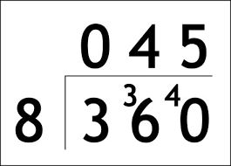
- 312 ÷ 8 =
- 306 ÷ 9 =
- 684 ÷ 2 =
- 382 / 8 =
- 305 / 7 =
- 451 / 12 =

Silver- I can divide by 1 digit using long division
- 1288 ÷ 4=
- 2568 ÷ 6=
- 8118 ÷ 9=
- 1893 ÷ 3=

Gold 1- I can divide by 2 digits using long division with exchanging
- 7212 ÷ 12 =
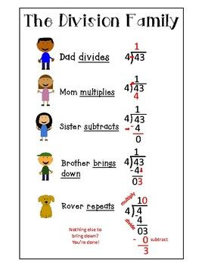
- 4465 ÷ 19 =
- 241 ÷ 17 =
- 1946 ÷ 31=

PLEASE TURN OVER FOR GOLD 2

Gold 2- I can apply these skills to reason and problem solve

3..
4.

