Geography | Religion | Seasons
Population/States | Areas of India | Anything else?
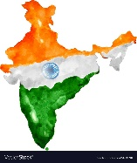
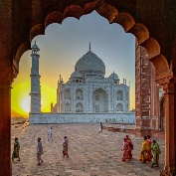
India

